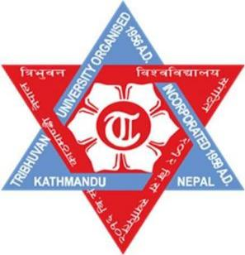
Tribhuvan University
Faculty of Humanities and Social Science
Swastik college, Bhaktapur

E-Governance (CACS409)
Case Study on
Nagarik App
Submitted By:
Safalta Shrestha (113102089)
Swosti Makaju (113102097)
BCA 7th Semester

Submitted To:
Daulat Rajbansi
Lecturer, BCA Department
Swastik college, Bhaktapur
June 2026

Acknowledgement

We would like to express our sincere gratitude to our teacher for their valuable guidance, encouragement, and continuous support during the preparation of this case study report. His suggestions and feedback greatly helped in improving the quality of this report.

We are also thankful to the concerned organizations and online resources that provided useful information regarding the Nagarik App and e-governance services in Nepal. Their information helped us understand the practical implementation of digital governance systems.

We would also like to thank our family members and friends for their motivation, support, and encouragement throughout the completion of this report.

Finally, we appreciate everyone who directly or indirectly contributed to the successful completion of this case study.

Abstract

This report presents a case study on the Nagarik App, a digital e-governance platform developed by the Government of Nepal to provide public services online. The purpose of this report is to analyze how digital technology can improve government service delivery and citizen accessibility.

The report addresses problems such as long queues in government offices, slow administrative processes, lack of transparency, and difficulty in accessing public services. The Nagarik App aims to solve these issues by offering online access to government documents and services through a mobile application.

The study also examines the benefits, challenges, implementation process, SWOT analysis, and future improvements of the system. This case study highlights the importance of e-governance in modern public administration and digital transformation in Nepal.

Table of Contents

Chapter-1 Introduction

Introduction
The Nagarik App is available for free download on the Google play store for Android phones aswell as the App Store for iPhones (now in Beta). Since it is in its early stages, it could be helpfulin this regard. However, many others have detailed issues with registration and mobileverification. Furthermore, it has been demonstrated that a lot of people's data is false. Since thisNagarik App is still being developed, any faults would be resolved in subsequent updates, as wellas the completed product will have a new, modern design. The Nagarik App would initially onlyprovide limited government services. This software displays how the Nepalese governmentappears online.To eliminate the bother of having to carry a mountain of proof of identity whileaccessing any public service divisions or agencies, the Nagarik App was designed as asmartphone device. On January 15, 2021, the beta version of it has been made available, with 50percent of the total of the services—including 9 federal services—in functioning. And ten daysafter launch, the app had indeed surpassed 100,000 downloads. However, it got several concernsabout problems with nationality Identification and recognition, and the full-official version'srelease was postponed. The app is available to all Nepali citizens who are in possession of a mobile number registered under your name and Citizenship details, or, Passport details, or, Details of voter ID card.

Background Study
The Government of Nepal has been working toward digital transformation and modernization of public services. Traditional government services in Nepal often required citizens to physically visit offices, wait in long queues, and complete paperwork manually. This process was time-consuming and inefficient.

To improve public service delivery, the Government of Nepal introduced the Nagarik App. It is a digital platform that allows citizens to access various government services through their smartphones.

Problem Statement
The major problems addressed by the Nagarik App include:
- Long waiting time in government offices
- Manual paperwork and administrative delays
- Lack of transparency in public services
- Difficulty in accessing government documents
- Increased transportation and service costs for citizens

1.4 Importance of the System
The Nagarik App is important because it promotes digital governance and improves communication between citizens and government agencies. It helps citizens access services quickly and securely without visiting government offices physically.

Benefits of Nagarik App
- Easy access to government services
- Reduction in paperwork
- Time and cost saving
- Improved transparency and accountability
- Better citizen satisfaction
- Digital identity verification
- Faster service delivery

1.5 Scope of the Study
This study focuses on:
- Features and functions of the Nagarik App
- E-governance implementation in Nepal
- Benefits and challenges of digital governance
- Recommendations for improvement

Limitations of the Study
- Limited access to internal government data
- Dependence on secondary sources
- Rapid technological changes may affect findings
- User experiences may vary in different regions

1.6 E-Governance Model
The Nagarik App mainly follows:
- Government-to-Citizen (G2C) Model
- Government-to-Government (G2G) Model
The app connects citizens directly with government services digitally.

1.7 Working method
The Nagarik App in Nepal is a mobile applica on that enables ci zens to accessvarious government services and informa on through their smartphones. The appworks in the following manner:
- Download and Installation : Users need to download and install the NagarikApp from their respec ve app stores (e.g., Google Play Store or Apple AppStore).
- Registration: Users need to register on the app by providing their personalinforma on and crea ng a user account. They also need to link their mobilenumber with their user account.
- Authentication: Once registered, users can log in to the app using theircreden als and authen cate themselves through biometric iden ca on( ngerprint or facial recogni on).
- Access to Services: The app provides access to various government servicessuch as passport applica on, driving license renewal, birth registra on,ci zenship cer cate, and so on. Users can select the service they require andfollow the steps provided by the app to complete the process.
- Payment: For some services, users need to make payments using the app'sintegrated payment gateway. They can pay using their credit or debit cards orthrough mobile wallets.
- Status Updates: Users can track the status of their service requests throughthe app and receive no ca ons when their requests are processed.

Chapter-2 Analysis

2.1 Problems Being Faced
Despite its benefits, the Nagarik App faces several challenges:
- Limited digital literacy among citizens
- Internet connectivity issues in rural areas
- Data privacy and cybersecurity concerns
- Technical errors and system downtime
- Limited integration with all government agencies

2.2 Methodology
The methodology used in this study includes:

2.2.1 Data Collection
- Government reports
- Online articles
- Research papers
- User reviews

2.2.2 Analysis Techniques
- SWOT Analysis
- Comparative Analysis
- Observation of app features

2.3 Application of Course Concepts
The case study applies several e-governance and information system concepts:
- Digital Transformation
- E-Governance Framework
- Public Service Automation
- Information Management System
- Mobile Governance (M-Governance)

2.4 SWOT Analysis

2.4.1 Strengths
- Easy access to government services
- User-friendly mobile application
- Reduces paperwork
- Saves time and transportation cost

2.4.2 Weaknesses
- Dependence on internet connectivity
- Limited awareness among rural citizens
- Technical problems during high traffic

2.4.3 Opportunities
- Expansion of digital services
- Integration with more government departments
- Promotion of cashless and paperless governance

2.4.4 Threats
- Cybersecurity risks
- Data breaches
- Resistance to digital adoption
- Technical infrastructure limitations

2.5 ER Diagram
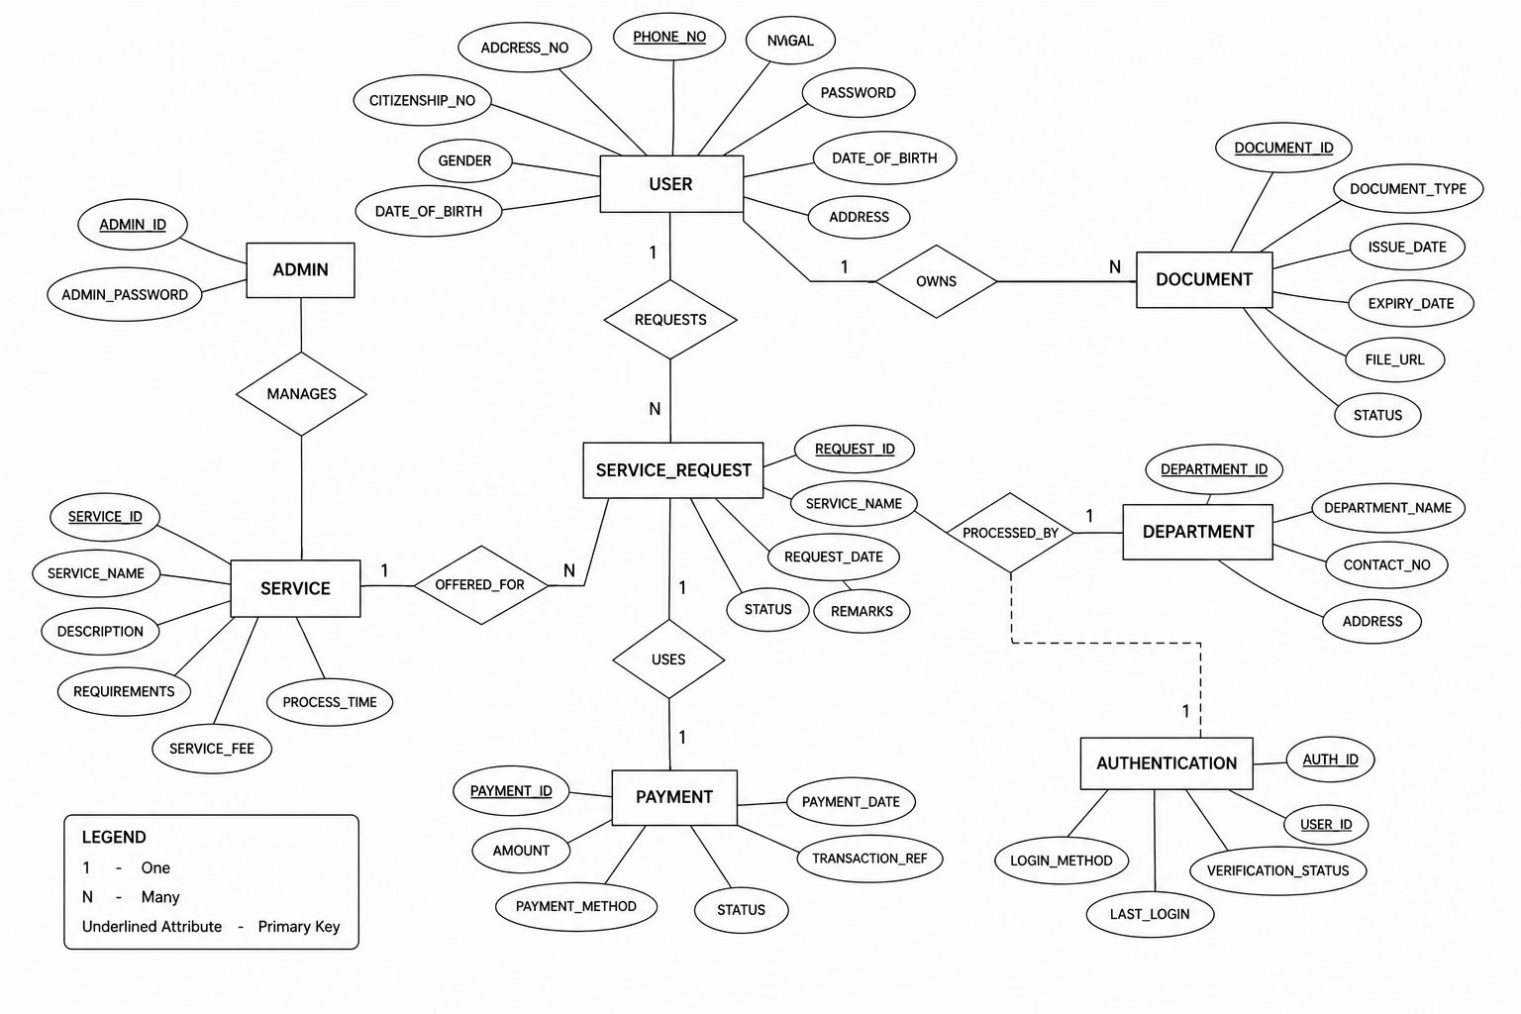

Chapter-3 Alternatives

3.1 Possible Alternatives

3.1.1 Alternative 1: Traditional Manual System:
Citizens physically visit government offices for services.

3.1.2 Alternative 2: Web-Based Government Portal
Government services are provided through websites only.

3.1.3 Alternative 3: Mobile-Based E-Governance System (Nagarik App)
Services are accessible through smartphones.

3.2 Decision Criteria
The following criteria can be used to evaluate alternatives:
- Accessibility
- Cost effectiveness
- Ease of use
- Service speed
- Security & Transparency
- User satisfaction
Among these alternatives, the Nagarik App is the most efficient and user-friendly option.

Chapter-4 Recommendation and Implementation Plan

4.1 Recommendation
It is recommended that the Government of Nepal further improve and expand the Nagarik App by increasing service integration, improving cybersecurity, and promoting digital literacy programs.

4.2 Implementation Steps
Step 1: Infrastructure Development
- Improve servers and cloud systems
- Increase internet accessibility
Step 2: Security Enhancement
- Implement stronger cybersecurity systems
- Use biometric and multi-factor authentication
Step 3: Public Awareness Programs
- Conduct digital literacy campaigns
- Train citizens to use the app effectively
Step 4: Integration of More Services
- Connect all government departments
- Add payment and tracking systems

4.3 Required Equipment and Expertise
- Software developers
- Cybersecurity experts
- Cloud infrastructure
- Database administrators
- Mobile application developers

4.4 Responsibility Distribution
Responsibility | Responsible Party
App Development | IT Team
Security Management | Cybersecurity Team
Public Awareness | Government Agencies
Maintenance | Technical Support Team

4.5 Time Frame

4.5.1 Short-Term Plan
- Bug fixing, Awareness campaigns, Server improvement

4.5.2 Medium-Term Plan
- Integration with additional services, Security upgrades

4.5.3 Long-Term Plan
- Nationwide digital governance expansion, Smart government ecosystem development

4.6 Estimated Cost
Costs may include:
- Software development, Server infrastructure, Security systems, Employee training, Public awareness campaigns

4.7 Organizational Impact
Positive impacts include:
- Faster service delivery, Reduced administrative workload, Better transparency, Improved public trust

4.8 Expected Problems
- Technical failures, Resistance from traditional users, Cybersecurity threats, Funding limitations

4.9 Contingency Plans
- Backup servers, Technical support centers, Regular system updates, Emergency recovery plans

4.10 Challenges During Implementation
- Low digital literacy, Poor internet connectivity, Data privacy concerns, Coordination among government departments

Chapter-5 Conclusion
This report discussed the Nagarik App as an important e-governance initiative in Nepal. The study showed how digital governance can improve public service delivery, transparency, and citizen satisfaction.

The report recommends expanding and improving the Nagarik App through better infrastructure, enhanced security, and wider service integration. Implementing these recommendations will help Nepal move toward a more efficient and modern digital government system.

Successful implementation of the recommendations will result in:
- Faster public services
- Reduced paperwork
- Increased transparency
- Better accessibility for citizens
- Stronger digital governance system
In the future, the Nagarik App can become a complete smart governance platform integrating all public services digitally across Nepal.

References
Government of Nepal Reports on E-Governance Official Nagarik App Information E-Governance and Digital Nepal Framework Reports Research Articles on Mobile Governance Information System and Public Administration Books Online Journals and Government Publications
---

Appendices

